**PROCEDURE FOR ISSUANCE OF DISABILITY CERTIFICATE AND UDID**

As per section 57 of the Rights of Persons with Disabilities Act 2016 (Act No.49 of 2016), guidelines issued under gazette notification S.O. 76(E) dated 4th January 2018 for the purpose of assessing the extent of specified disabilities and as per rule 22 and 23 of The Mizoram Rights of Person with Disabilities Rules 2017 the following procedure is laid out for assessment and certification of persons with benchmark disabilities:

Any person with specified disability may apply in **Form VI** of the Rule, for a disability certificate either online **through Unique Disability Identity Portal** (www.swavalambancard.gov.in) **or** submit the **physical application** to a medical authority in the district of the applicant's residence as mentioned in the proof of residence in the application.





The dealing assistant on behalf of the medical authority will verify the information



0

The medical authority shall assess person with disabilities and after being satisfied that the applicant is a person with benchmark disability

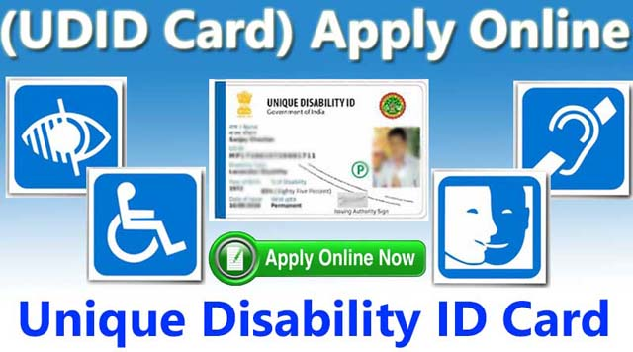

Issue a disability certificate in his favour through the Unique Disability ID (UDID) portal.

**Ineligible for issue of disability certificate**

If an applicant is found ineligible for issue of disability certificate, the medical authority shall convey the reasons to him in writing under **Form VII** of the Rules within a period of one month from the date of receipt of the application.

Issued in public interest by

Health & Family Welfare Department

Govt. of Mizoram

Further details can be obtained from the H&FW and SWTA department’s websites

For applications other than online mode, the dealing assistant on behalf of the medical authority shall ensure that the application is converted to the online mode and shall follow the same procedure as provided above for issuance of disability certificate. Alternately after obtaining the approved disability certificate, the applicant or any person on his behalf should submit it to the concerned dealing assistant of the district for generating UDID card.