Rights of Persons with Disabilities Act 2016 (Act No.49 of 2016) section 57-a tarlan ang leh Gazette notification S.O. 76(E) dated 4th January 2018 hmanga rualbanlohna neite endikna leh The Mizoram Rights of Person with Disabilities Rules 2017 rule 22 leh 23 in rualbanlohna tehfung (Benchmark Disability) tlin te endikna leh certification pekna atan a hnuaia kalphung hi siam a ni:

Mi tu pawh chiang taka rualbanlohna nei nia hriatte chuan Rule-a Form VI hmangin disability certificate dilna chu **Unique Disability Identity Portal (www.swavalambancard.gov.in)** kaltlangin emaw dilna form-a kan awmna district kan tarlanna **District Medical Authority**-te hnenah a hmunah kalin dilna thehlut theih a ni.

**DISABILITY CERTIFICATE leh UDID nei tura zawm tur leh pekchhuah dan**



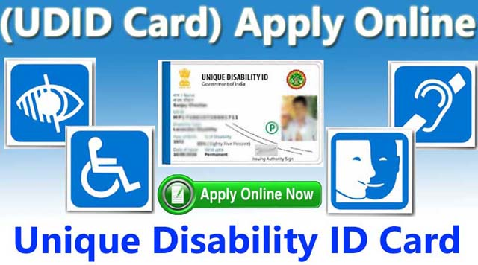

**Mipui vantlang tan Health & Family Welfare Department,**

**Govt. of Mizoram in a tihchhuah a ni**

A chunga tarlan bak chipchiar zawka hre duh tan H&FW leh SW&TA department website-ah en theih a ni

Online ni lova dilna te chu medical authority aiawha buaipuitu chuan dilna chu online ah a dah lut ngei tur a ni a, disability certificate pekchhuahna atana a chunga tarlan angin a ti ngei tur a ni. Disability certificate a dawn hnuah, a diltu emaw a aiawh tu chuan UDID card siam turin district-a file khawihtu hnenah a thehlut tur a ni.

**Disability certificate pek chhuah theih loh**

Diltu chu disability certificate pe tura tehfung a tlin lo nia hriat a nih chuan, medical authority in dilna a dawn atanga thla khat chhungin a chhan chiang taka tarlangin Rule-a Form VII hmangin ziakin a hriattir ang.

Unique Disability ID (UDID) portal kaltlangin disability certificate chu pek chhuah a ni ang

Medical authority chuan diltu chu rualbanlohna tehfung (benchmark disability) a tlin ngei a ni tih ang

Medical authority aiawha lo buaipuitu in kan dilna chu a lo enfiah ang